 | 10.1.20 Editors - Compositor Editor - Header - Add Menu - Utilities
Table of content
Detailed table of content 1
Add menu - Utilities 3
Levels 3
Normalize 4
Split 4
Switch 4
Index Switch 5
Menu Switch 6
Switch Stereo View 7
Relative to Pixel 7

Detailed table of content
Detailed table of content
Detailed table of content 1
Add menu - Utilities 3
Levels 3
Inputs 3
Image 3
Properties 3
Channel 3
Outputs 3
Mean 3
Standard Deviation 3
Normalize 4
Inputs 4
Value 4
Outputs 4
Value 4
Split 4
Inputs 4
Position 4
Rotation 4
Image 4
Image 4
Outputs 4
Image 4
Switch 4
Properties 5
Switch 5
Inputs 5
Off 5
On 5
Image 5
Index Switch 5
Properties 5
Data Type 5
Inputs 5
Index 5
0 5
1 5
Output 6
Output 6
Menu Switch 6
Properties 6
Data Type 6
Inputs 6
Menu input 6
A 6
B 6
Output 6
Output 6
A 6
B 6
Switch Stereo View 7
Inputs 7
Left 7
Right 7
Outputs 7
Image 7
Relative to Pixel 7
Inputs 7
Value 7
Image 8
Properties 8
Data Type 8
Reference Dimension 8
Outputs 8
Value 8

Add menu - Utilities

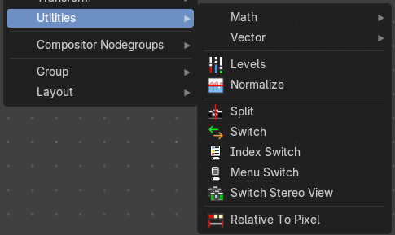
Here you find nodes that are used as utilities.

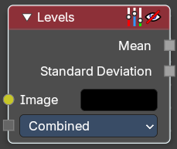
Levels
The Levels Node reads the inputs color channels and outputs analytical values. It’s useful for evaluating image brightness and contrast, and for driving effects based on image intensity.

Inputs

Image
The image input.

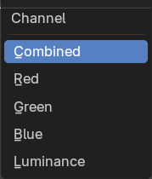
Properties

Channel
The Red, Green, Blue or Luminance channels

Outputs
1D values based on the levels of an image.

Mean
The mean is the average value of all image pixels in specified channel (combined, red, green, blue, luminance). It tells you how dark or bright the image is and can be used as such for setups that depend on how is input “bright” or “dark”.

Standard Deviation
How much those pixel values differ from the mean. A low standard deviation indicates that the pixel values tend to be very close to the mean. A high standard deviation indicates that the values are spread out over a large range of values.
The visualization of such data is just a gray rectangle.

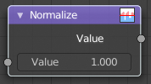
Normalize
Find the minimum and maximum values of a single channel. Then map the values to a range of 0 and 1.

Inputs

Value
Standard value input.

Outputs

Value
Standard value output.

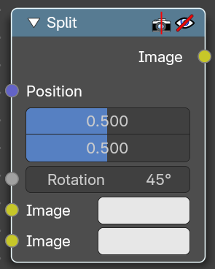
Split
Allows to combine two images horizontally or vertically

Inputs

Position
Line position where the image should be split.

Rotation
Line angle where the image should be split.

Image
The first image.

Image
The second image.

Outputs

Image
Image output.

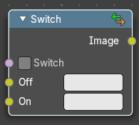
Switch
The Switch node is akin to a boolean, where you can use a toggle to choose what is shown with on or off.

Properties

Switch
The toggle that turns the switch on or off resulting in the final output being whatever is in the on or off input.

Inputs

Off
The image that is shown when the toggle is off.

On
The image that is shown when the toggle is on.

Image
Standard RGB image output.

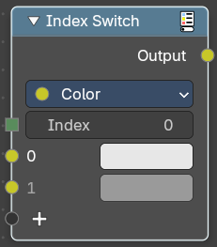
Index Switch
Choose between an arbitrary number of values with an index.

Properties

Data Type
What data type to evaluate.

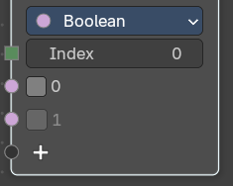
Inputs
The content changes. dependant of the data type.

Index
The index input value.

0
The 0 value

1
The 1 value

Output

Output
The output index value.

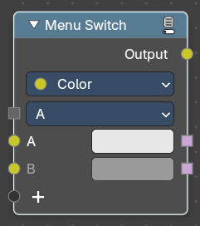
Menu Switch
Select from multiple inputs by name.

Properties

Data Type
What data type to evaluate.

Inputs
The content changes. dependant of the data type.

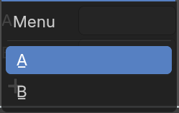
Menu input
The default menu.

A
The A input.

B
The B input.

Output

Output
The output string.

A
The A output

B
The B output

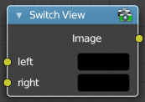
Switch Stereo View
The Switch View node combines the views (left and right) into a single Stereo 3D output. This can be useful if for example, you need to treat the view as separate images by combining each of the views.

Inputs

Left
Left-eye image input.

Right
Right-eye image input.

Outputs

Image
Stereo 3D image output.

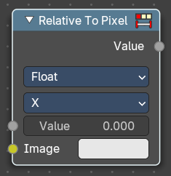
Relative to Pixel
The Relative to Pixel node converts values expressed as relative factors (e.g., percentages of image size) into absolute values. This is especially useful when working with nodes that require pixel-based inputs, such as filters or masks, while still allowing for resolution-independent setups.
Example: Converting a Value of 10 Using “Per Dimension”
Let’s say you’re working with an image that’s 1920 pixels wide and 1080 pixels tall with the following input value and properties.
- Mode: Per Dimension
- Input Value: 10% (or 0.10 as a relative value)
- Value Type: 2D Vector (0.10, 0.10)
Using Per Dimension type, each component of the vector is multiplied by its respective X and Y image dimension:
- X = 0.10 × 1920 = 192 pixels
- Y = 0.10 × 1080 = 108 pixels
Resulting Pixel Value: (192, 108)

Inputs

Value
The input float value to convert. This would be your absolute value.

Image
The reference image used to determine pixel dimensions. If not connected, the active compositing image is used.

Properties

Data Type
Specifies whether the input is a Float or a Vector. This affects how the conversion is applied.

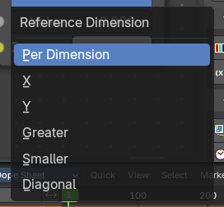
Reference Dimension
Determines how the relative value is interpreted.
Per Dimension: Converts each component (X and Y) relative to its corresponding image dimension.
X: Converts the value relative to the image width.
Y: Converts the value relative to the image height.
Greater: Uses the larger of the image’s width or height as the reference.
Smaller: Uses the smaller of the image’s width or height.
Diagonal: Uses the diagonal length of the image as the reference.

Outputs

Value
The converted float value, based on the selected mode and input type.

